EXPNO 13: CREATE A VIRTUAL MACHINE WITH 1 CPU, 2GB RAM AND 15GB STORAGE DISK USING A TYPE 2 VIRTUALIZATION SOFTWARE.
DATE:
AIM: To create a virtual machine with 1 cpu, 2gb ram and 15gbstorage disk using a type 2 virtualization software.
PROCEDURE:
STEP 1:Dowload VMware workstation and installed as type 2hypervisor.
STEP2:Dowload ubuntu or tiny OS as iso image file.
STEP 3: In VMware workstation->create new VM.
STEP 4: Do the basic configuration settings.
STEP 5: Created tiny OS virtual machine.
STEP 6: Launch the VM.
DESIGN:
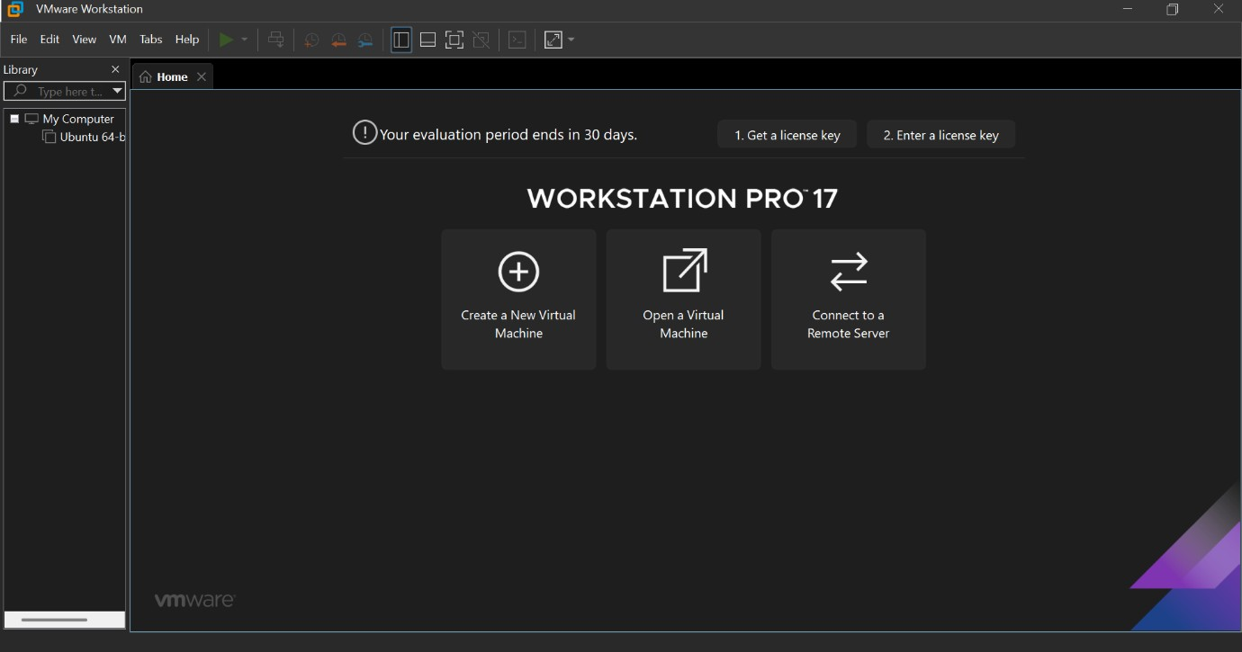
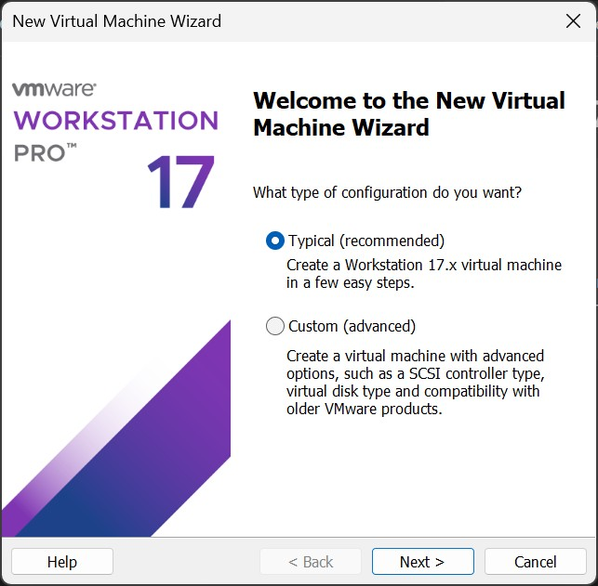

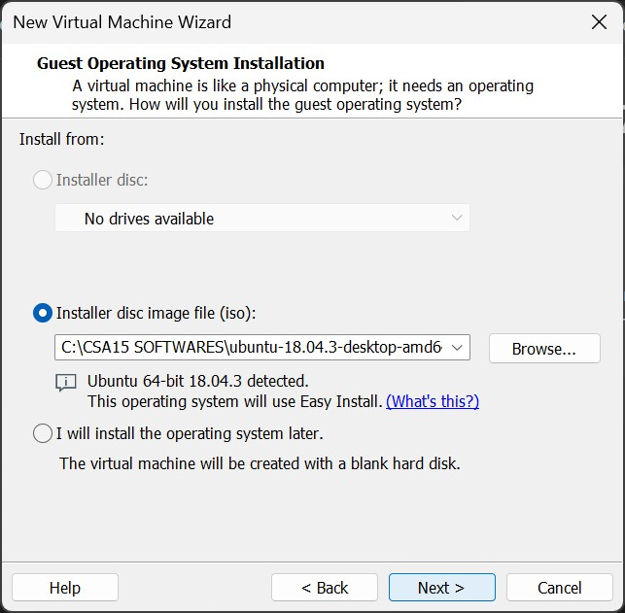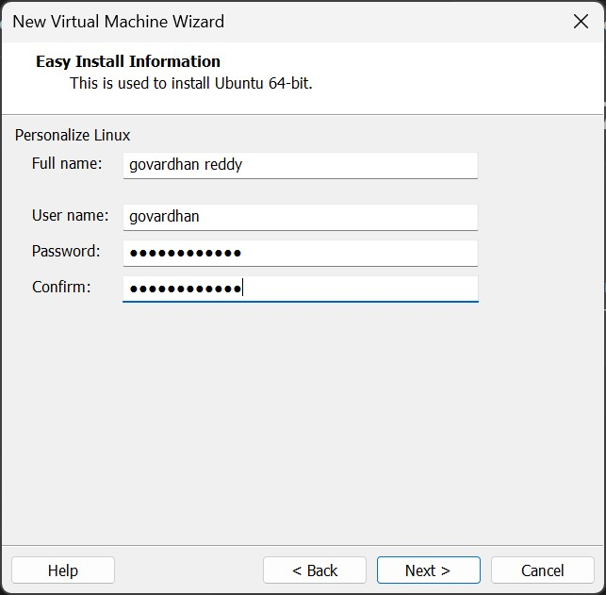

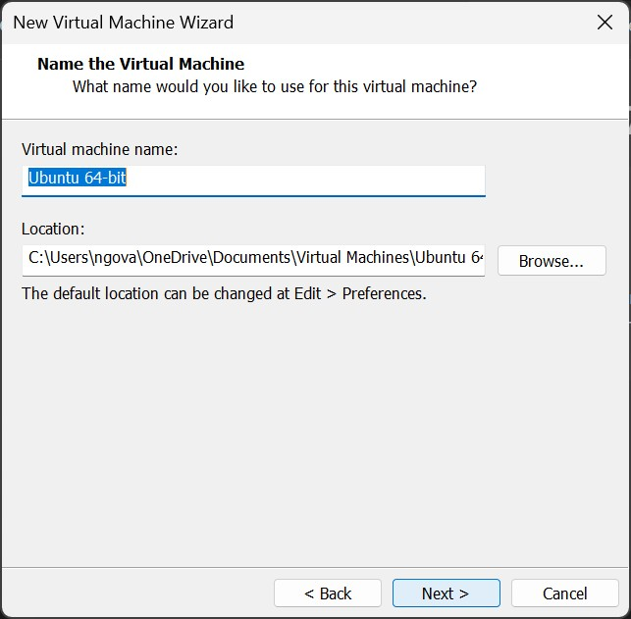

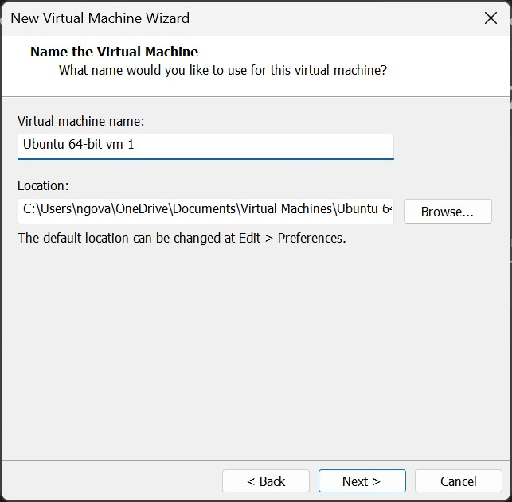
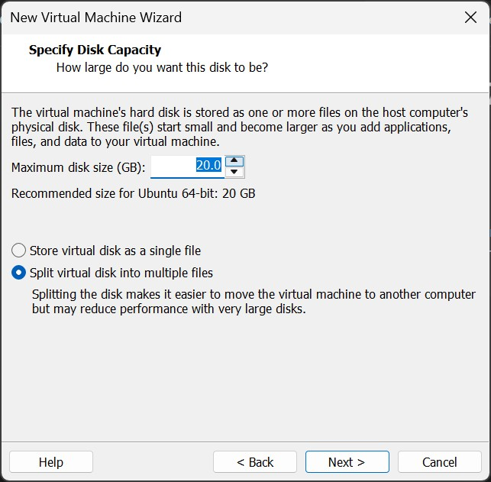

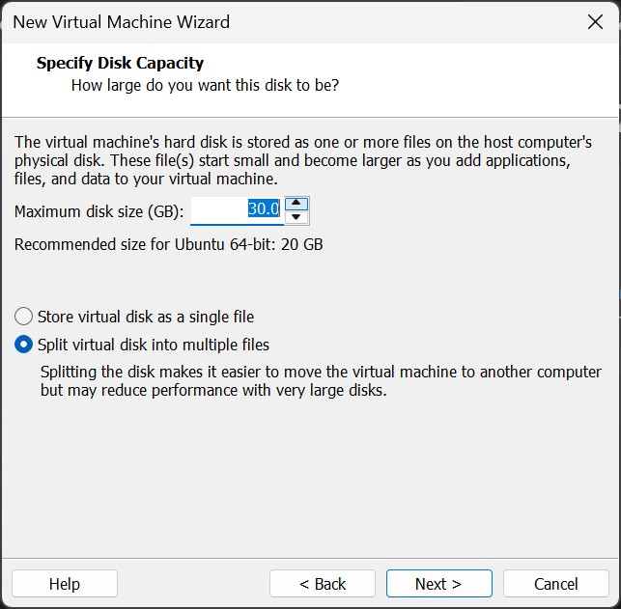
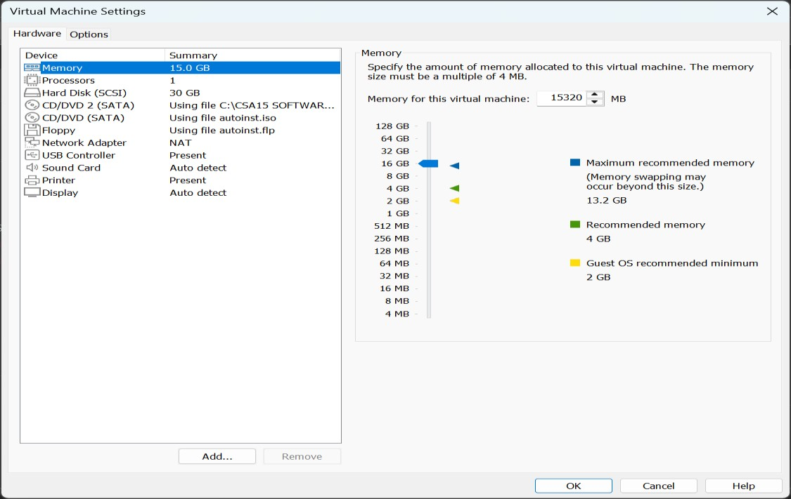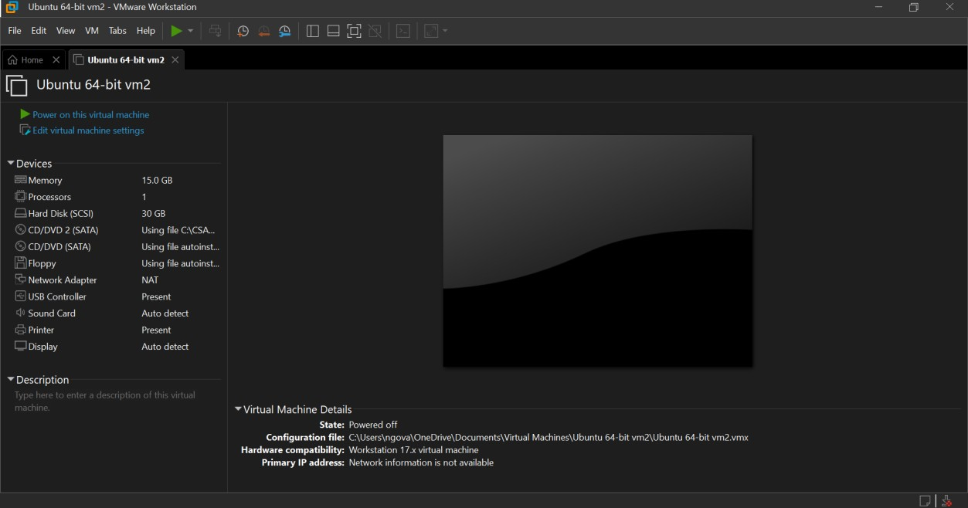

RESULT:
Successfully Created a virtual machine with 1 CPU, 2gb ram and 15gb storage disk using a type 2 virtualization software.

